**PROJECT REPORT**

**• INTRODUCTION:**

Overview:

Vehicle Management is an application where a customer Details are stored in order to choose cars, bikes and commercial vehicles for travel with in the city. The data which is stored here is further used to remind them if any offers are provided during the seasons and any updates regarding vehicles are sent to them in the form of messages and mails.

•Objectives:

The Vehicle Management System (VMS) is an application for the Automotive industry. It supports, in the area of Sales & Services, the business processes that you require as vehicle importer when dealing with your original equipment manufacturers (OEMs) and your dealers in new and used vehicle sales.

Develop a comprehensive vehicle management system that can be customized to the needs of any organization.

Implement a user-friendly interface that allows users to access and manage vehicle data from any device.

Integrate the system with other relevant applications such as accounting and inventory management systems.

Provide real-time analytics and reporting features to help organizations make data-driven decisions about their fleet management.



**Key Features:**

Vehicle inventory management

Sales tarcking

Maintainance and service scheduling

Customer relationship management

Reports and dashboards

Mobile access and integration with third party systems

**Detailed Steps to Solution Design:**

* Creating a developer org in salesforce.

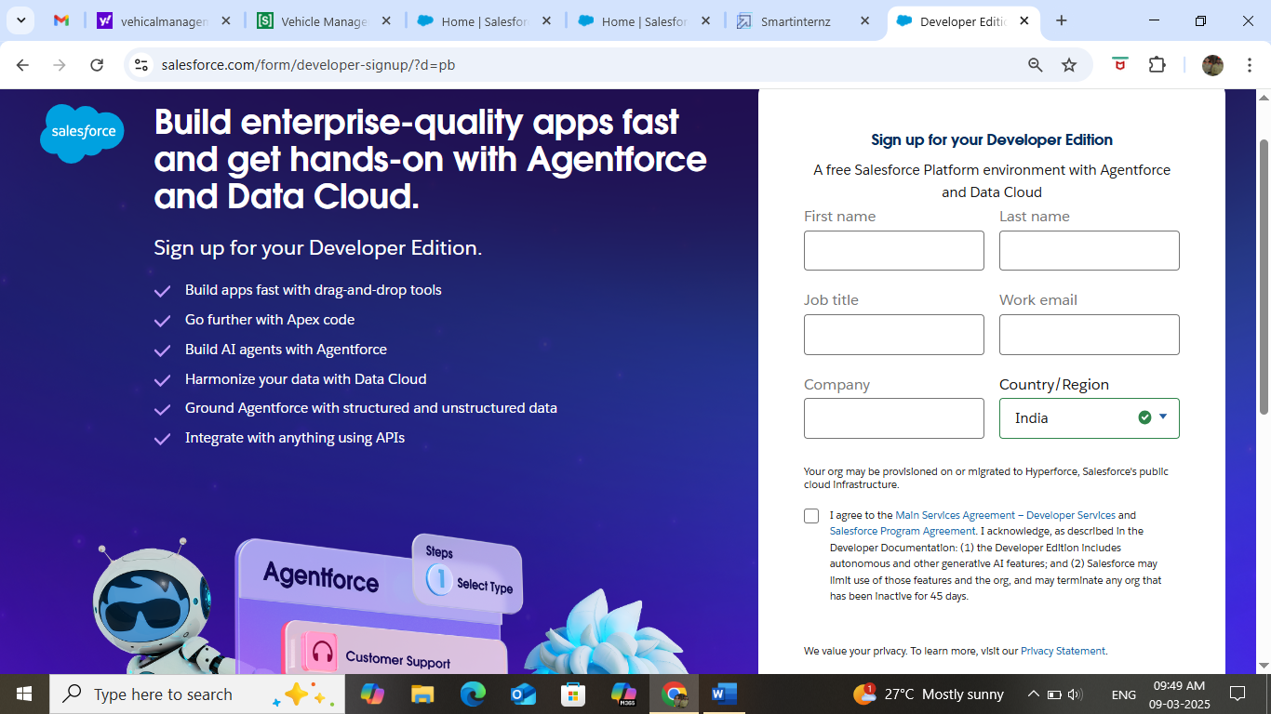

**Creating Custom objects:** Vehicle, Driver, Traveler.

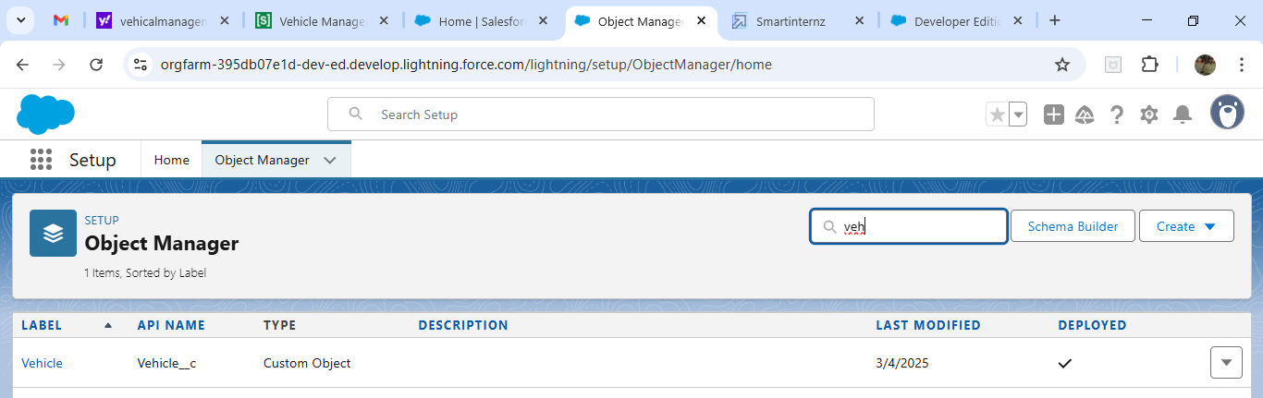

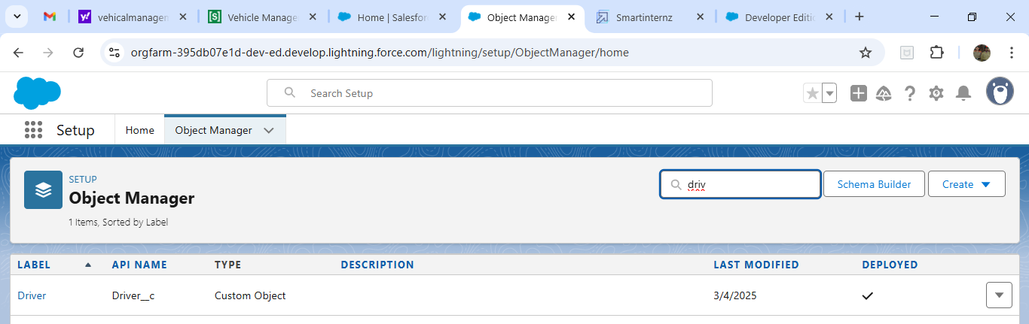

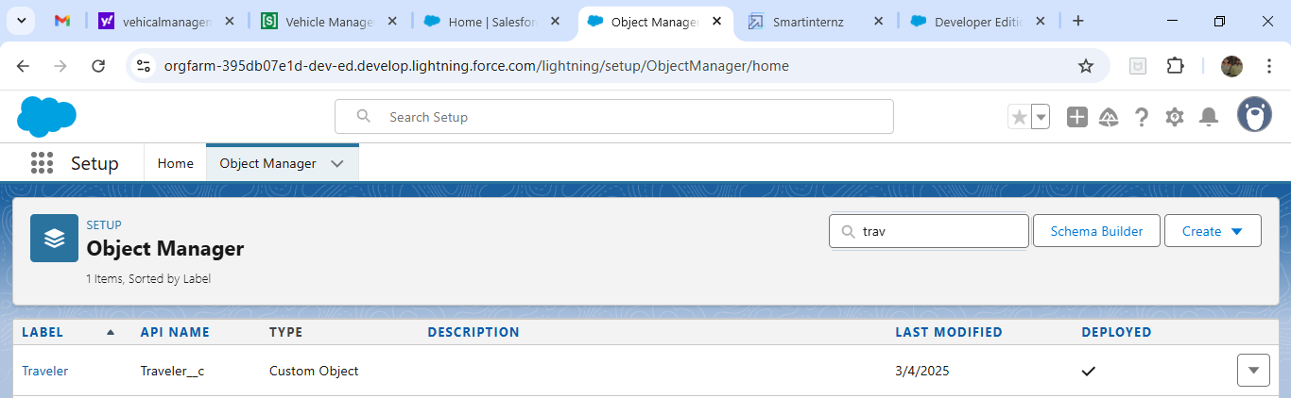

**\* Creation of fields**

**\* Creation of Fields in Vehicles objects**

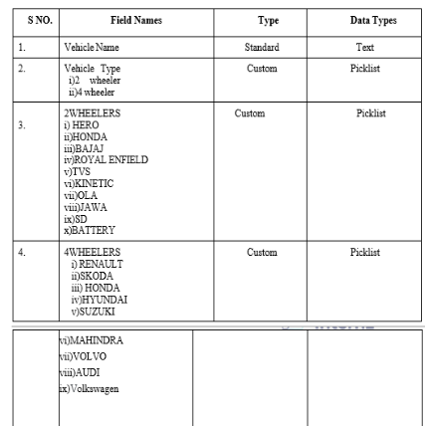

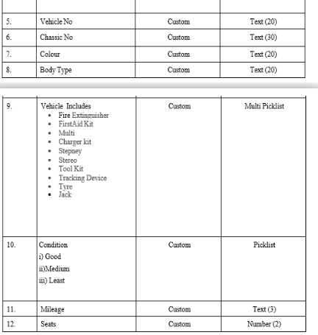

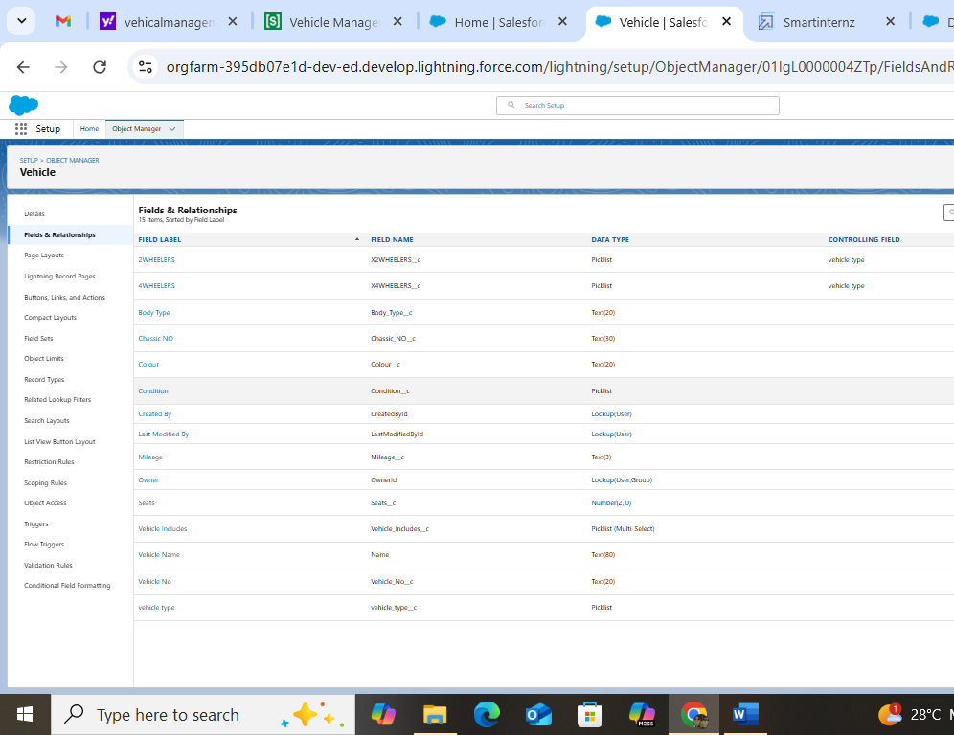

**Fields in Driver objects follow below data types**

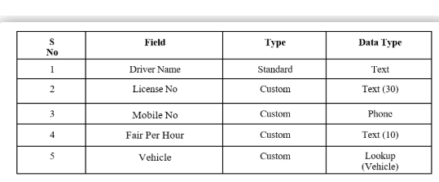

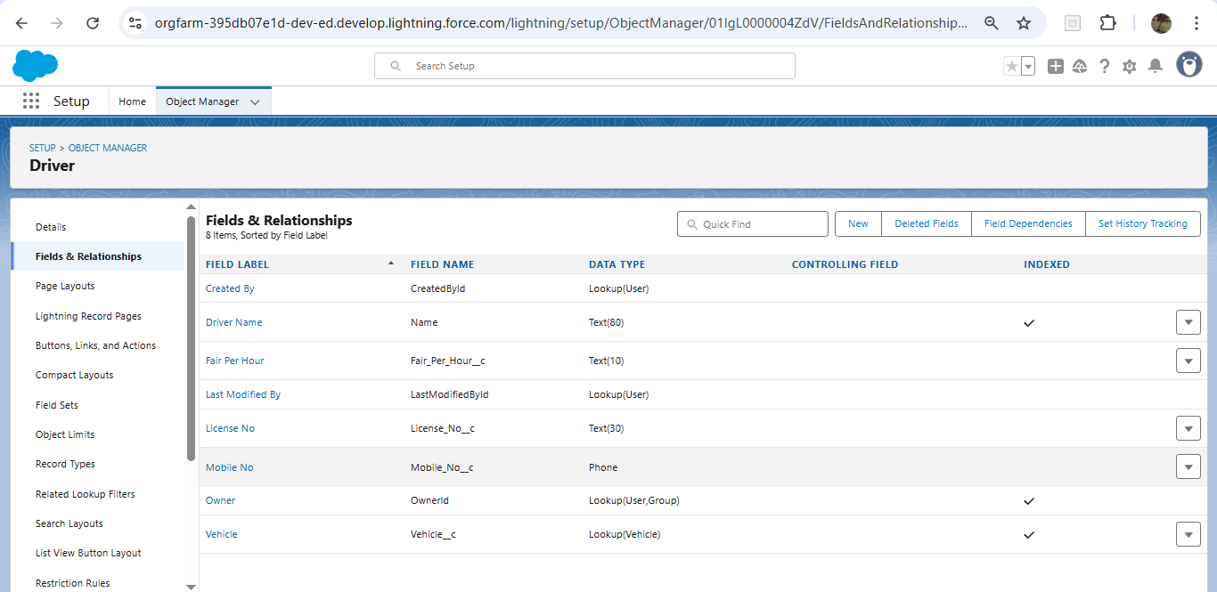

**Fields In Traveler Objects Follow Below Data Types**

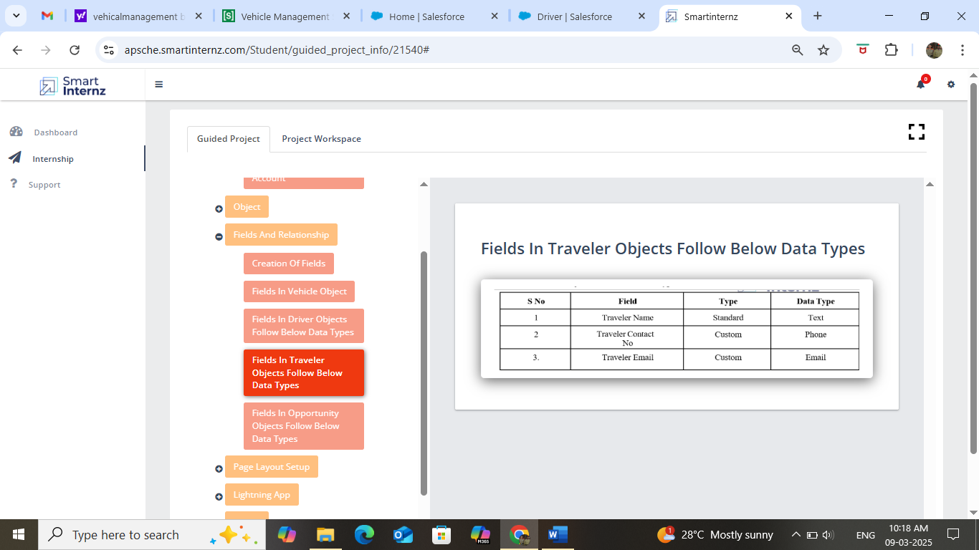

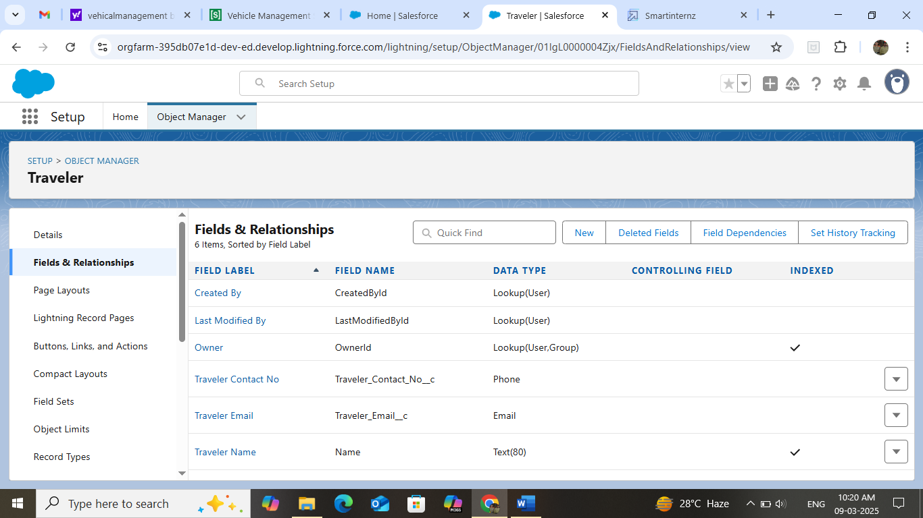

**Fields in Opportunity objects follow below data types**

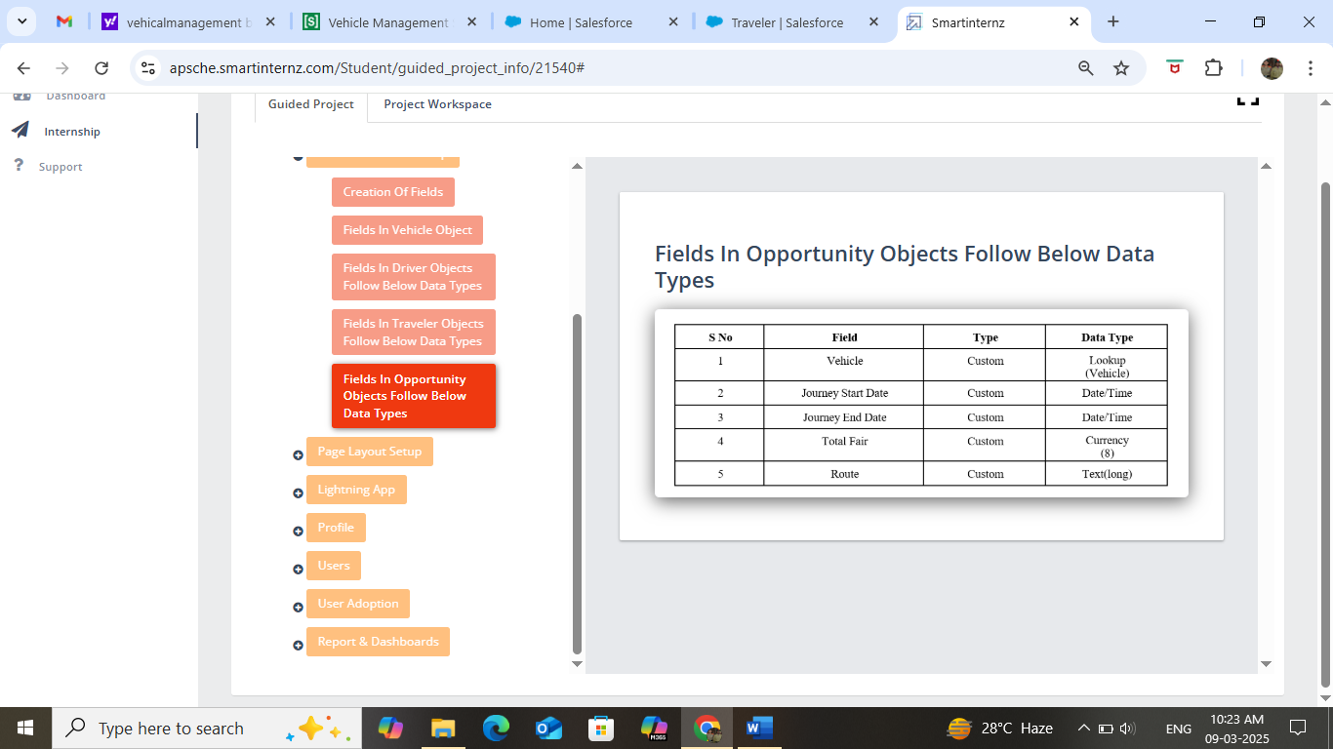

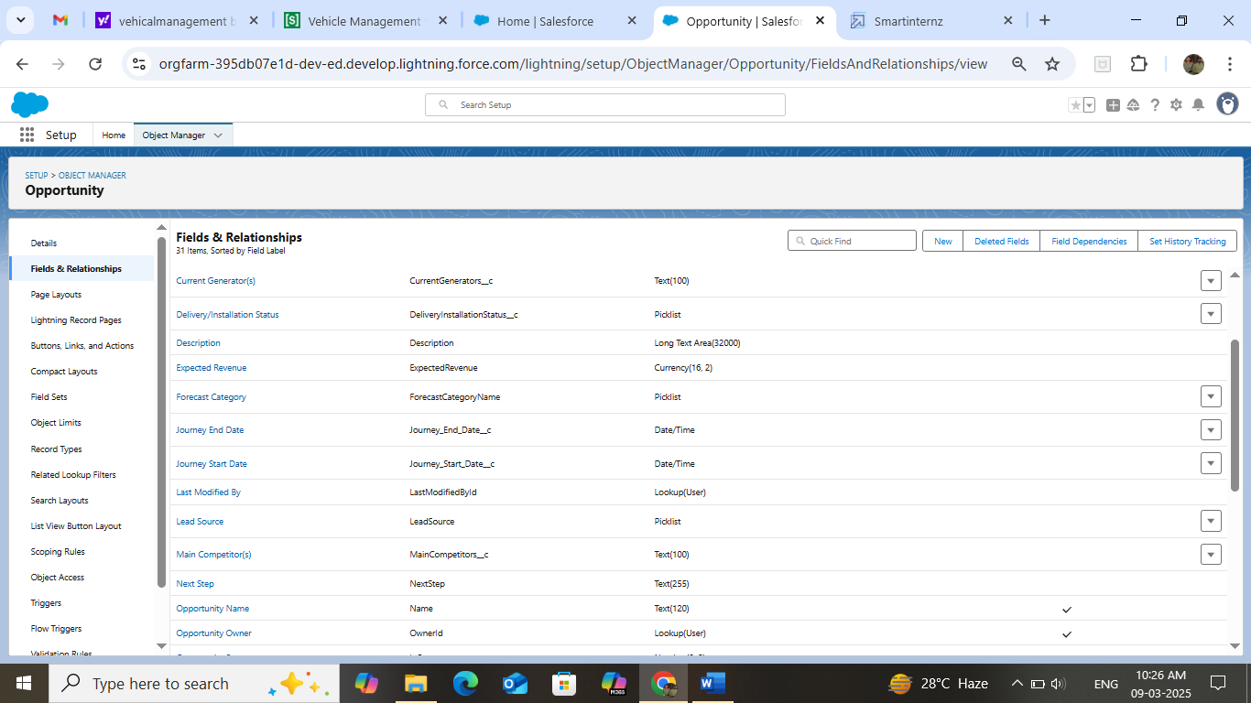 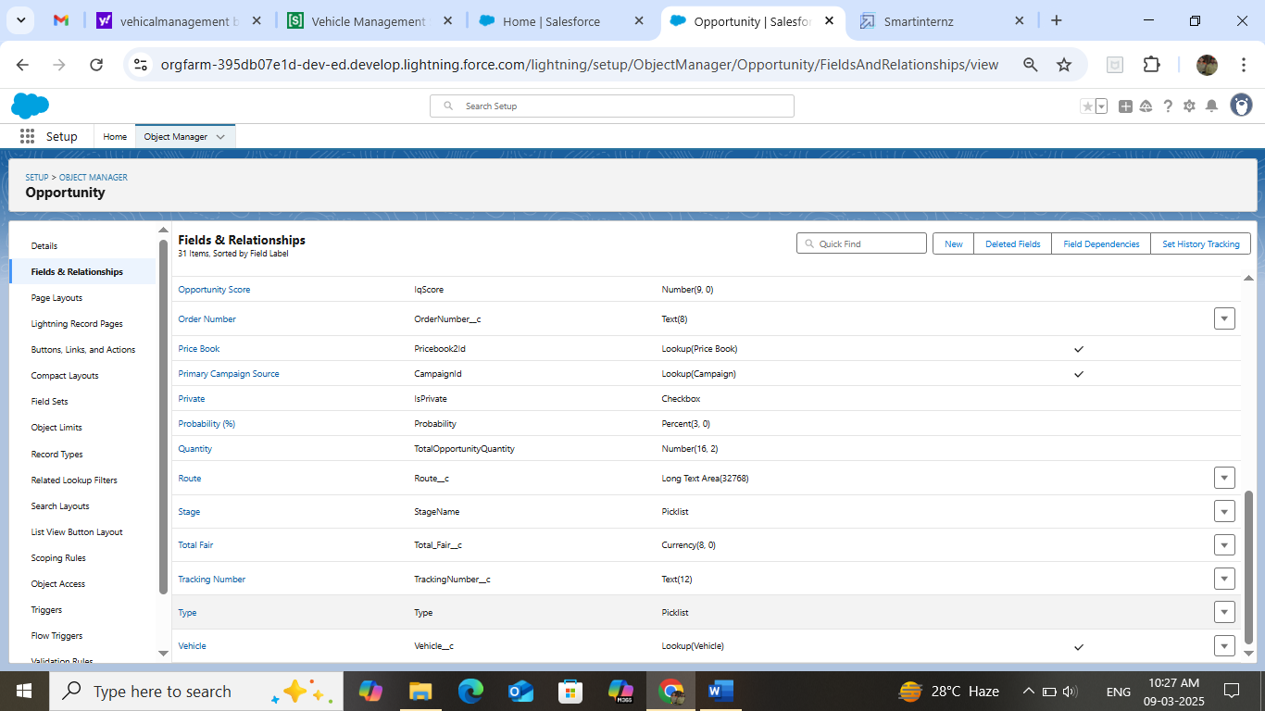

**Create the Vehicle Management Lightning app**

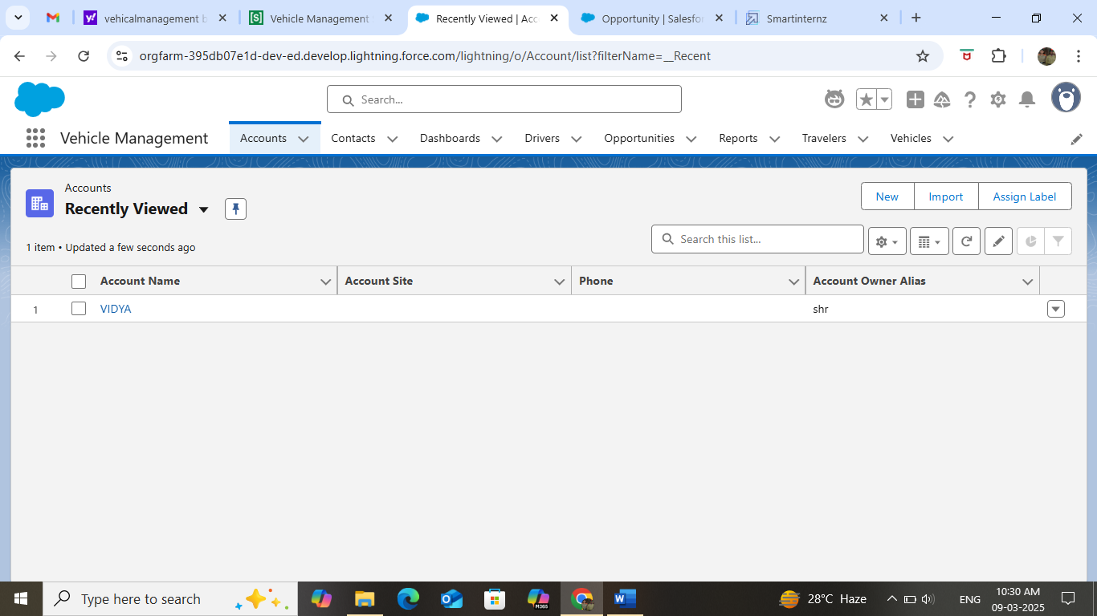

 create a Vehicle Manager profile

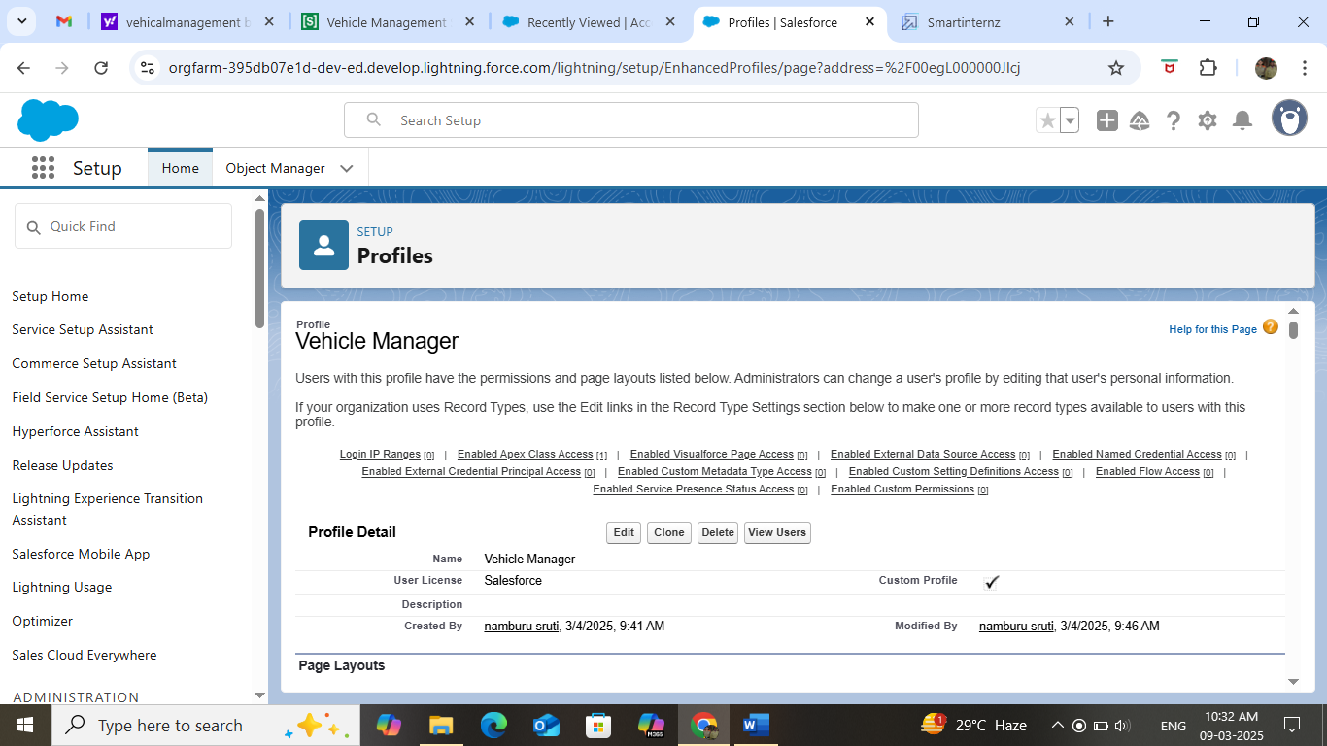

Setup Roles: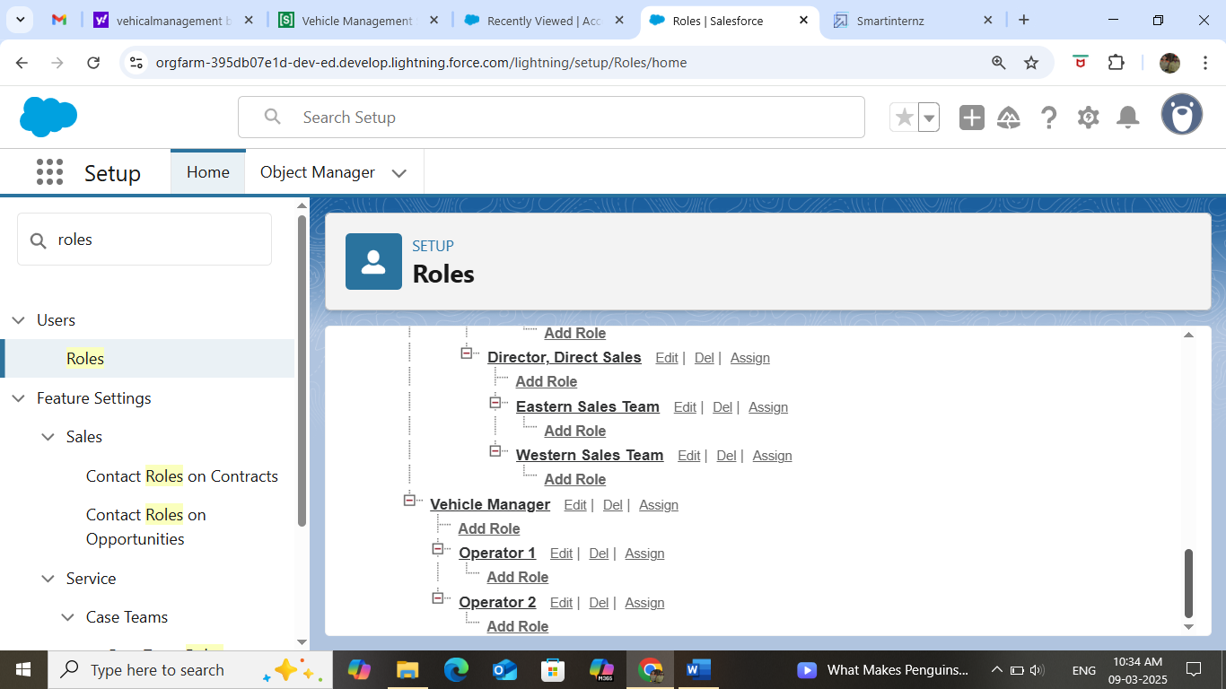

**Creating a User**

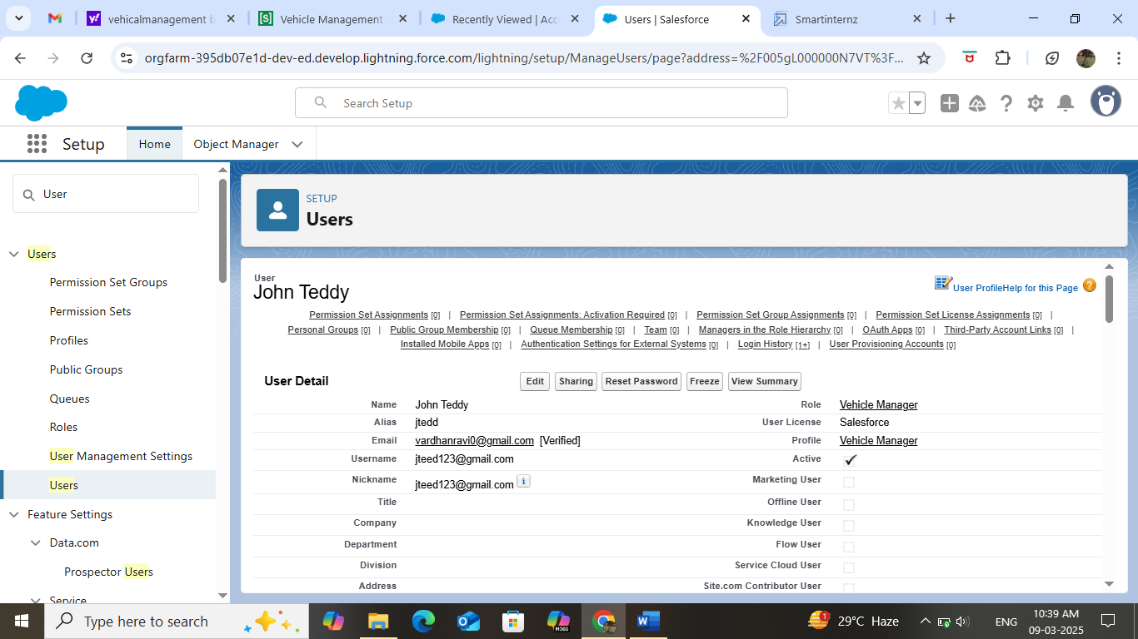

**Testing and Validation:**

*Field Dependencies;

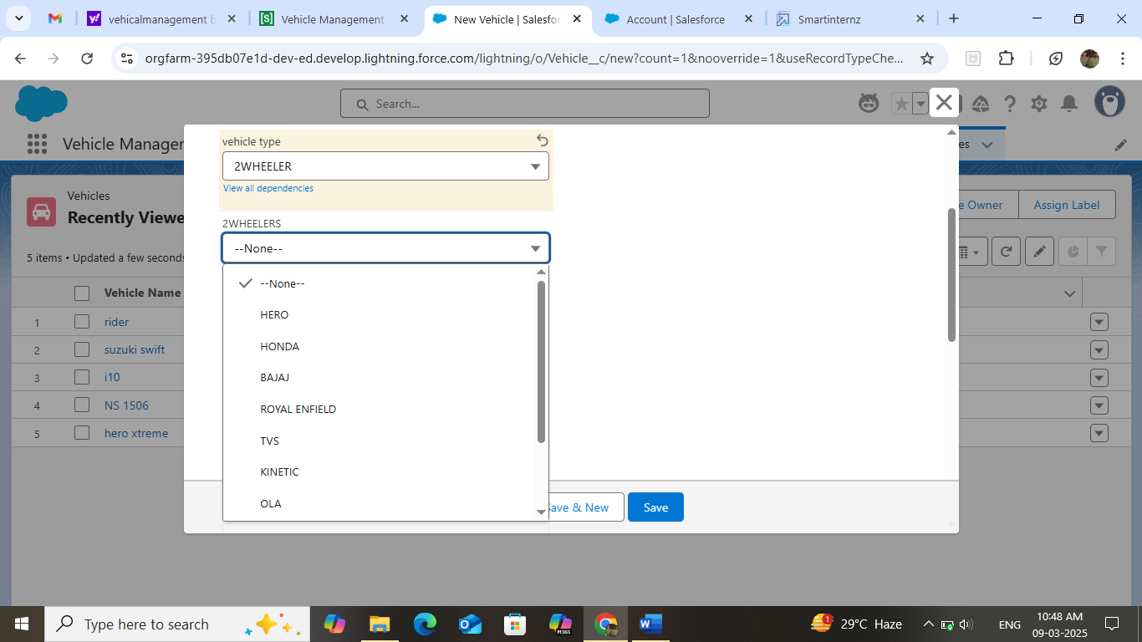

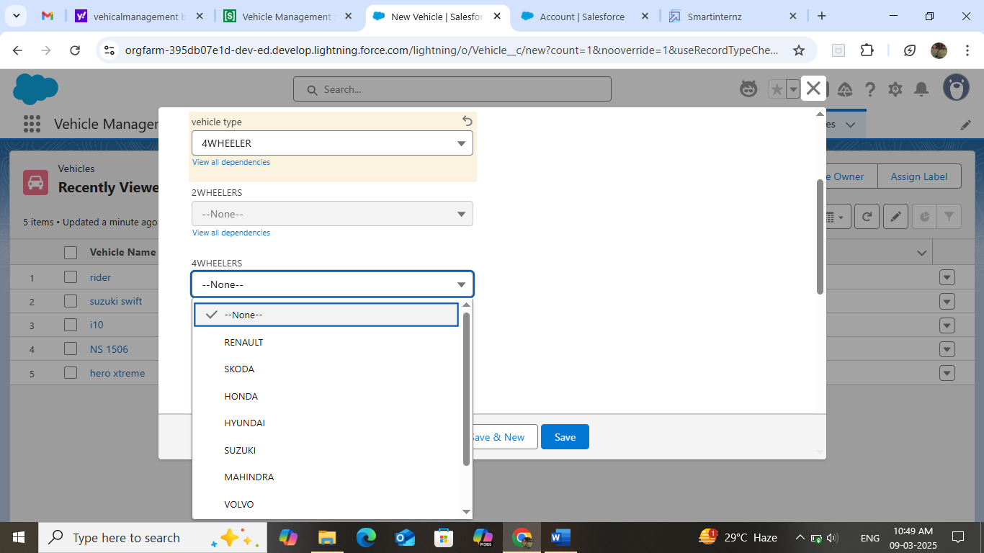

* CONCLUUSION:

The Vehicle Management System is a powerful tool for organizations that want to manage their fleet of vehicles efficiently. Built using Salesforce , it provides a customizable and user-friendly interface that allows users to access and manage vehicle data from any device. Its advanced features, such as maintenance scheduling, fuel consumption tracking, and driver management, help organizations optimize their fleet utilization and reduce costs. With real-time analytics and reporting features , the system enables data-driven decision making and helps organizations stay ahead of the competition.